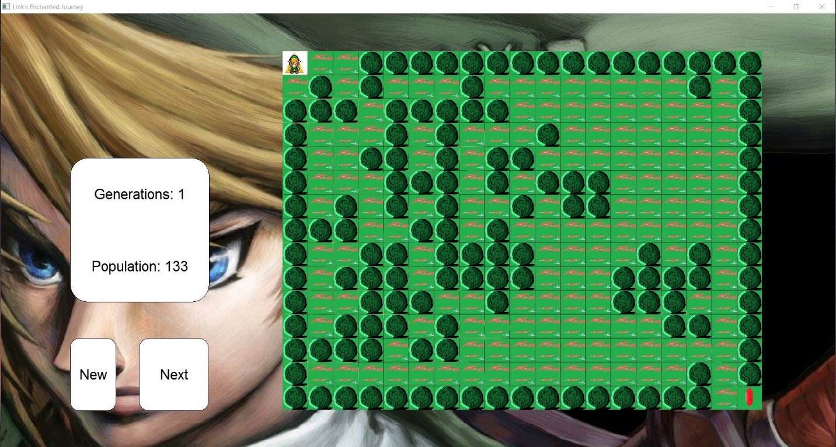

Link’s Journey

Zelda was captured in the night by the evil henchmen of Ganondorf. Ganondorf has grown very strong since Link’s last victory and now Link is unable to defeat him. The only way Link can save her is to collect enough Rupees in the Enchanted Forest to bribe Ganondorf.

The goal of this game is to collect the Rupee in the level and continue onto the next level. Also avoid getting eaten by the new spawning trees every 5 moves.

Use the arrow keys or a/s/d/w to move Link one space in the forest. The forest will be changing throughout the level as follows: Every 5 moves,

If a tree is neighbored by 3 trees, it will remain alive. However, if there is 1 or less the tree will die out.

If an open patch of the forest is neighbored by exactly 3 trees, a tree will grow in that spot. Otherwise it will remain open.

If a tree is surrounded by 4 or more trees, the tree will also die out.

Link can call upon the Forest Spirits by blowing a gale from his ancient branch. This means that he can cut down a tree in front of him if needed; however, he can only do this 10 times per level.

The game will keep track of how many moves it took Link to reach the Rupee.

The journey is finished when Link collects 10 Rupees or when Link is eaten by a tree.

SAVE ZELDA FROM GANONDORF!